Preposition

🟠 What is a Preposition?
# Source: AI Source: Provided by: [Data Path: Persons Table -> ID Column: 1, Name_En Column: Motasem Essam] -> From: [Chatgpt (GPT-4-turbo)] on [7/24/2025]
A preposition is a word that shows the relationship between a noun (or pronoun) and another word in the sentence.
It usually tells us about time, place, direction, cause, or manner.

📘 Definition:
# Source: AI Source: Provided by: [Data Path: Persons Table -> ID Column: 1, Name_En Column: Motasem Essam] -> From: [Chatgpt (GPT-4-turbo)] on [7/24/2025]
A preposition links a noun or pronoun to another word in the sentence, showing their relationship — often in terms of time, place, or direction.

🧠 Common Prepositions:
# Source: AI Source: Provided by: [Data Path: Persons Table -> ID Column: 1, Name_En Column: Motasem Essam] -> From: [Chatgpt (GPT-4-turbo)] on [7/24/2025]
Time | Place/Location | Direction/Movement | Other Relationships
at, on, in | at, in, under | to, into, onto, across | with, about, of, for

✳️ Examples of Prepositions in Sentences:
# Source: AI Source: Provided by: [Data Path: Persons Table -> ID Column: 1, Name_En Column: Motasem Essam] -> From: [Chatgpt (GPT-4-turbo)] on [7/24/2025]
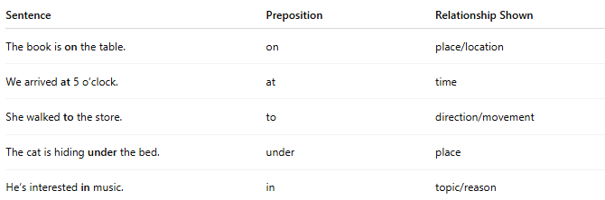

Sentence | Preposition | Relationship Shown
The book is on the table. | on | place/location
We arrived at 5 o’clock. | at | time
She walked to the store. | to | direction/movement
The cat is hiding under the bed. | under | place
He’s interested in music. | in | topic/reason

⚠️ Prepositions are followed by nouns or pronouns, not verbs.
# Source: AI Source: Provided by: [Data Path: Persons Table -> ID Column: 1, Name_En Column: Motasem Essam] -> From: [Chatgpt (GPT-4-turbo)] on [7/24/2025]
- ❌ Incorrect: She is good at sing.
- ✅ Correct: She is good at singing.

✅ Summary:
# Source: AI Source: Provided by: [Data Path: Persons Table -> ID Column: 1, Name_En Column: Motasem Essam] -> From: [Chatgpt (GPT-4-turbo)] on [7/24/2025]
A preposition connects a noun or pronoun to another word, showing relationships like time, place, direction, or reason.

